Boston University

Electrical & Computer Engineering

EC463 Senior Design Project

**Final Prototype Testing Plan & Report**

***SharkCam***

## 

## 

## 

## by

Team 28

SharkCam

Team Members

Liron Dubin (ME)

Brett Senders (ME)

Kevin Vasquez (ME)

Sophia Delia (CE)

Alex Hureaux-Perron (EE/CE)

## 

## Testing Goals:

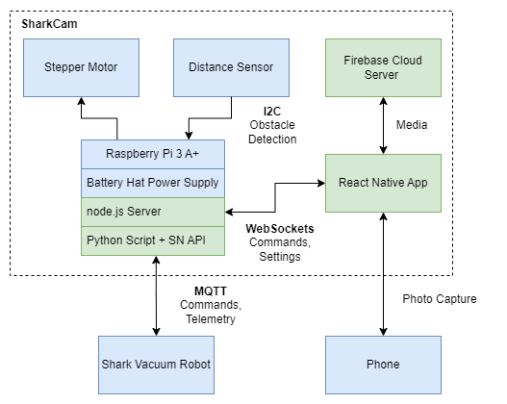

* Test all completed systems and components
  + **Software/Networking**
    - Mobile app to Pi communication (one-way)
    - Pi to Robot control
    - Obstacle avoidance with distance sensor
    - App to FIrebase server communication
    - App interface and operation
  + **Hardware**
    - Phone holder
    - Column
    - Stability
    - Base

## Required Materials

Hardware:

* Shark robot
* GL-MT300N-V2 router
* Mobile phone
* Raspberry Pi 3 A+
  + Battery hat power supply
  + ToF sensor VL53L4CD
* Column
* Phone mount assembly
  + Phone holder
  + Motor mount & bearing
  + Distance sensor target
  + Shaft
* Base assembly
  + Semi-permanent base
  + Electronics bay

Software:

* Python scripts & MQTT API
  + Robot control script
    - Obstacle avoidance
* React Application
  + Deployed via Expo Go
* Firebase server

## Testing Overview

The final prototype testing campaign will evaluate and demonstrate all completed . These will include powering all hardware devices with the battery hat power supply, control of the robot over a local network using the Raspberry Pi, and opening the mobile device camera from the React application.

## Testing

#### **App and Photo Database**

#### Procedure

1. Take picture from app
2. Upload to Firebase
3. View photo from app

#### Criteria

* App can take photos
* Photos can be uploaded to server and viewed from app
* Settings can be changed inside app

#### **Hardware**

#### Procedure

1. Attach column to base
2. Extend column
3. Place phone in holder

#### Criteria

* Column attaches securely to base
* Phone is held securely in holder
* Entire system remains stable and attached when robot accelerates and stops

#### **Robot Control**

#### Procedure

1. Trigger photo capture from app
2. Trigger obstacle avoidance while robot is operating

#### Criteria

* App can trigger robot to move
* Robot pauses and rotates while obstacle is detected
* Robot resumes when obstacle is no longer detected

## Results

#### *Final test conducted 4/20/23*

#### **Hardware**

* Phone mount securely holds phone
* Column remains stable while robot is underway
* Motor is slightly underpowered but can turn phone

#### **Obstacle Avoidance**

* System detects obstructions to distance sensor
* Robot stops moving and rotates until obstruction is cleared
* Robot may try to move back to object when it returns to autonomous mode if near wall and no-go zone has not been set

#### **App**

* Capture interval can be set in app
* Robot operation can be triggered and suspended from app
* Photos are captured and uploaded to Firebase
* Previously captured photos can be viewed